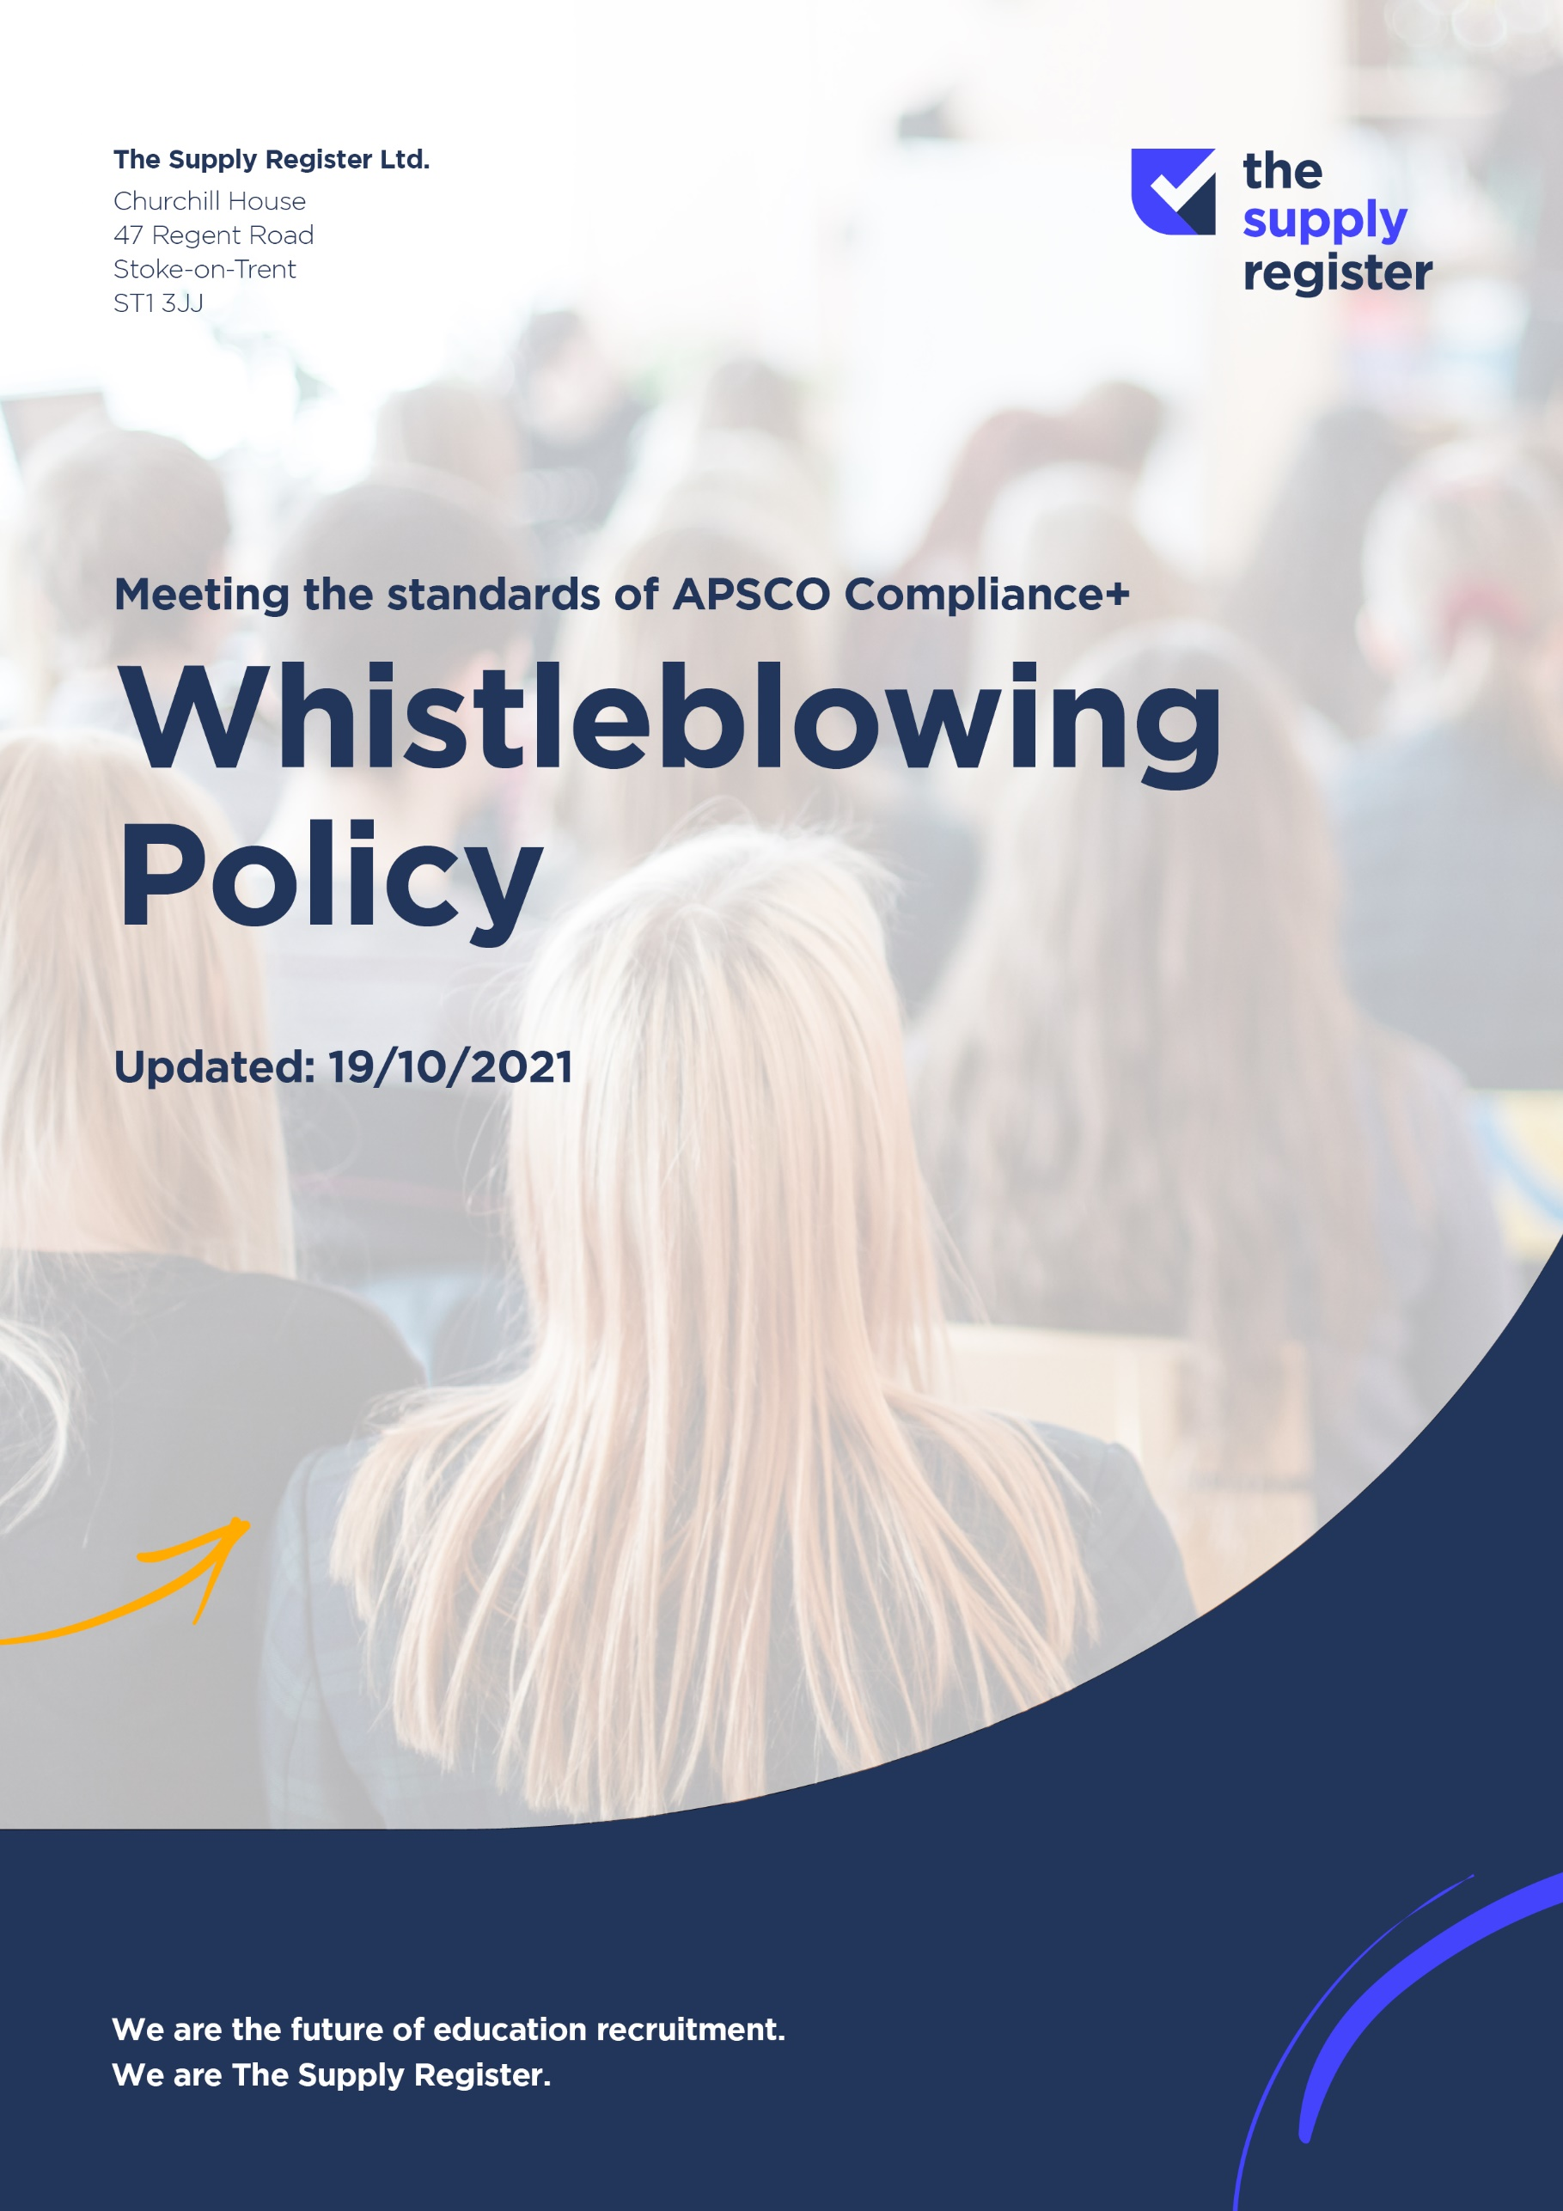

WHISTLEBLOWING POLICY

Policy Statement
The Supply Register Ltd encourages a free and open culture in dealings between its managers, employees, and all people with whom it engages in business and legal relations. In particular this company recognises that effective and honest communication is essential if concerns about breaches or failures are to be effectively dealt with and the company’s success ensured.

This policy is designed to provide guidance to all those who work with or within the company who may from time to time feel that they need to raise certain issues relating to the company with someone in confidence.

Workers who in the public interest raise genuine concerns under this policy will not under any circumstances be subjected to any form of detriment or disadvantage as a result of having raised their concerns.

Background
The Public Interest Disclosure Act 1998 recognised that workers have the right to “blow the whistle” and disclose certain information, e.g. fraudulent activities, malpractice and/or concerns about health and safety.

The Act introduced specific rights for those who disclose information to a third party about an alleged wrong doing in defined circumstances. There is no general right for all so-called whistle-blowers to receive special protection. To qualify, the following issues must be met:

- The Disclosure in question must relate to one of the specified categories contained within the Act; and
- The Disclosure must be made in one of the ways specified.

Procedure
This policy will apply in cases where workers genuinely believe that one of the following sets of circumstances is occurring, has occurred or may occur within the company and that it is in the public interest for the employee to disclose it. The matters that may be disclosed in this way are that:

- A criminal offence has been committed, is being committed or is likely to be committed; or
- A person has failed, is failing or is likely to fail to comply with any legal obligation to which s/he is subject; or
- A miscarriage of justice has occurred, is occurring or is likely to occur; or
- The health or safety of an individual has been, or is being or is likely to be endangered; or
- The environment has been, is being or is likely to be damaged, or
- Information tending to show any massive failing within any one of the proceeding paragraphs has been, is being or is likely to be deliberately concealed.

We aim to encourage anyone with a genuine concern to raise it by providing the facility to make the complaint to someone who has no direct involvement with the issue. The issue should be reported to a director or another responsible person in a senior position. If there is not a sufficiently senior person to deal with the complaint within the organisation, external routes should be considered, as set out by the Act. The matter will be dealt with objectively and in a confidential manner. If you have a concern, do not wait until you have proof or investigate the matter yourself; a reasonable suspicion will suffice, i.e. where you reasonably believe that the information disclosed is substantially true.

However, there are two important exceptions where the Disclosure will not qualify for protection and they are:

- If the person making the Disclosure commits an offence by making it, or
- It is a matter in which a legal, professional privilege would apply, namely, correspondence between the employer and their lawyers regarding a specific case.

The Supply Register Ltd will not take action against anyone who raises a complaint under these policies in good faith because they did so, however, employees who make false allegations maliciously may be subject to the appropriate disciplinary action. This Whistle Blowing Policy does not cover private grievances, including complaints about individual employment matters. A ‘whistleblower’ is a witness, not a complainant.

