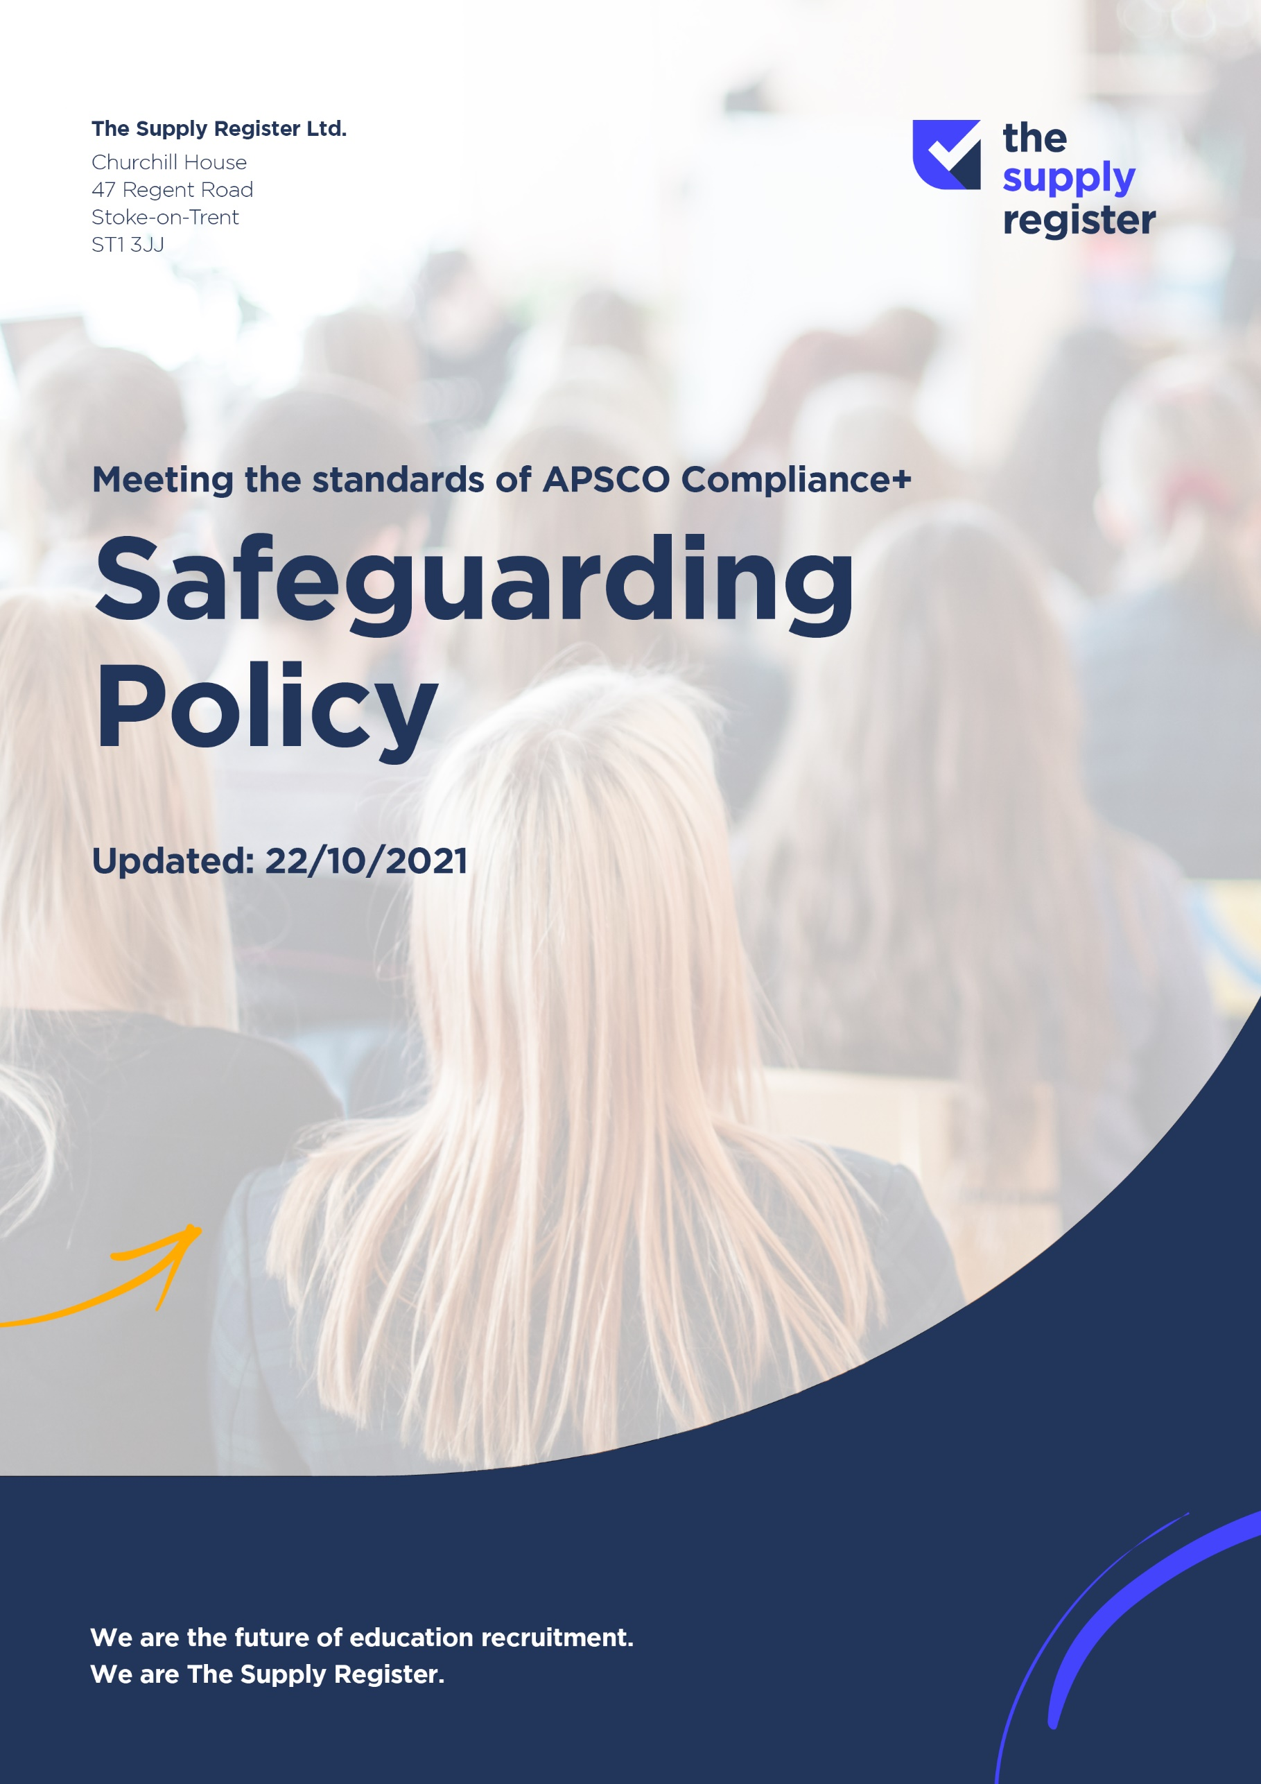
SAFEGUARDING POLICY
Designated Safeguarding Officer: Baljinder Kuller
Designated Safeguarding Officer Contact details: Baljinder Kuller
Tel: 01785 472481
Email: baljinder.kuller@supplyregister.uk
Date: 22 October 2021
This policy will be reviewed every 6 months. Review Date: April 2022

1. Introduction
Safeguarding is everyone’s responsibility. The Supply Register Ltd acknowledges the duty to safeguard and promote the welfare of children and is committed to ensuring safeguarding practice that reflects statutory responsibilities, government guidance and complies with best practice requirements. All children, regardless of age, disability, gender, racial heritage, religious belief, sexual orientation or identity, have the right to equal protection from all types of harm or abuse.

This policy applies to all internal staff and candidates and will be widely promoted and be mandatory for everyone involved in The Supply Register Ltd. Failure to comply with this policy and the company’s safeguarding procedures may result in disciplinary action being taken, including termination of employment and/or contract.

All candidates placed by The Supply Register Ltd are expected to familiarise themselves with arrangements for safeguarding children in the organisation where they are placed and to have a clear understanding regarding abuse and neglect in all forms; including how to identify, respond and report.

Here at The Supply Register Ltd we expect all staff, and candidates to follow and promote good practice in safeguarding. In order to do so, they should:

- Read, understand, accept and act in accordance with this policy.
- Be vigilant and follow professional codes of conduct to maintain professional boundaries and safe working practices.
- Report any concerns or disclosures related to the protection and safety of children.
- Undertake mandatory safeguarding training and awareness sessions where provided.
- Help educate learners/service users in placements regarding matters of keeping safe, including acting as a good role model.

Our Commitment to Safeguarding
This policy is designed to meet the above principles by ensuring that:

- The Supply Register Ltd has robust safer recruitment processes that ensures that those who are known to be a risk to children do not gain access to them.; those whose actions suggest that they are a risk to children are detected at the earliest stage and prevented from continuing to work with children; and that those who intend to do harm are prevented at every possible stage from entering the workforce.
- Staff and candidates understand their roles and responsibilities in respect of safeguarding and are provided with appropriate learning opportunities to recognise, identify and respond to signs of abuse, neglect and other safeguarding concerns relating to children.
- There is an open and transparent culture which enables staff and candidates to raise concerns around children, those that work with children, and processes within The Supply Register Ltd
- It is as simple as possible for an individual to report concerns about harm or risk and clear procedures are implemented where safeguarding and child protection issues arise. Where concerns are reported The Supply Register Ltd will ensure that individuals are supported.
- The Supply Register Ltd has robust policies and procedures in place, which are reviewed and updated at least every 12 months.
- The Supply Register Ltd stays up to date with developments on safeguarding best practice, reporting and auditing safeguarding activities annually and addressing any areas for improvement.
- The Supply Register Ltd will report any concerns regarding any individual, or any potential safeguarding situation that it becomes aware of as soon as practicable to the appropriate authority and will co-operate in any ongoing investigations or assessments.
- The Supply Register Ltd will work in partnership with other services (including local authority children’s social care) to ensure that those who are identified as being at risk of abuse are protected.
- Confidential, detailed and accurate records of all safeguarding concerns are maintained and securely stored.

2. Relevant Legislation and Guidance
The principal legislation and guidance governing this policy is:

- Working Together to Safeguard Children 2018 (HM Government)
- Keeping Children Safe in Education 2021 (Department for Education)
- The Children Act 1989
- The Children Act 2004
- Guidance for Safer Working Practice for Adults Who Work with Children and Young People (2019)
- Information Sharing: Guidance for practitioners and managers. HM Government (2018)
- Rehabilitation of Offenders Act 1974
- Disqualification under the Childcare Act 2006 (2015)
- Counter Terrorism and Security Act 2015 (including the 'Prevent Duty')
- The Prevent Duty, Departmental, Advice for Schools and Child Care Providers (2015).
- Modern Slavery Act 2015
- Human Rights Act 1998
- Local Safeguarding Partners/Arrangements

This policy should be read in conjunction with our other relevant safeguarding policies, such as:
- Health and Safety Policy
- Allegations Policy
- Complaints Policy
- Code of Conduct
- Safer Recruitment
- Information Sharing Policy

3. The role of the Designated Safeguarding Officer (DSO)
The role of the DSO includes:
- Ensuring that all relevant staff and candidates have received safeguarding training appropriate to their role and continue receiving training to enable the development of skills and good practice when working with children.
- Receiving and responding appropriately to all reports of safeguarding issues or abuse which are raised by staff members, partner agencies or candidates.
- Ensuring that confidential, detailed and accurate records are kept of any concerns, reports or referrals related to candidates or children that they work with.
- Liaising with Designated Safeguarding Leads/Officers in partner organisations.
- Acting as a source of support, advice and expertise for staff and candidates with concerns and liaising with other agencies and professionals.
- Supporting staff and candidates involved in safeguarding incidents and assisting them in challenging or reporting poor or unsafe practice.
- Referring any allegations of abuse or safeguarding concerns to the relevant children’s social care and if relevant, the police and/or the Local Authority’s Designated Officer (LADO). In order to do this, the DSO will need to consult the Local Safeguarding Partnership Arrangements for the area in which the organisation is located. Further details on referral routes are located in Working Together to Safeguard Children (2018) and in Keeping Children Safe in Education (2021).
- Reporting concerns to the Disclosure and Barring Service (DBS), this may be where a staff member or candidate has been dismissed or left, where serious concerns have been raised about their conduct or behaviour, and the company believes they pose a risk to children. The DSO will complete the necessary referral documents to the DBS and liaise with them thereafter if they have any further questions regarding the staff member or candidate.
- Keeping senior management appraised of any safeguarding incidents and their outcome.
- Liaising with the Company’s Compliance Officer and senior management regarding training and skill development programmes available to staff and candidates.
- Policy development (or overseeing this, including ensuring that all policies are updated as and when needed, but in any event on an annual basis.

4. Definitions

According to the Children Act 1989, a ‘child’ is anyone who has not yet reached their 18th birthday. The fact that a child has reached 16 years of age, is living independently or is in further education, is a member of the armed forces, is in hospital or in custody in the secure estate for children and young people, does not change his or her status or entitlement to services or protection under current legislation.

In this policy, the terms ‘child’ and ‘young person’, or ‘children’ and ‘young people’, are used interchangeably to refer to any individual under the age of 18.

Abuse and neglect are forms of maltreatment. Somebody may abuse or neglect a child by inflicting harm, or by failing to act to prevent harm.
The Children Act 1989 defines ‘harm’ as “ill-treatment or the impairment of health or development”. ‘Development’ means physical, intellectual, emotional, social or behavioural development; ‘health’ means physical or mental health; and ‘ill-treatment’ includes sexual abuse and forms of ill-treatment which are not physical. As a result of the Adoption and Children Act 2002, the definition of harm also includes “impairment suffered by hearing or seeing the ill-treatment of another”

Abuse may be perpetrated by an individual from the child’s school, community, family, those in a position of trust or another child.

All staff should be aware that children can abuse other children (often referred to as peer on peer abuse). This is most likely to include but may not be limited to: bullying (including cyberbullying), physical abuse, sexual violence, sexual harassment, up-skirting, sexting (also known as youth produced sexual imagery); and initiation/hazing type violence and rituals.

Child abuse can be one of four different categories as set put in Working Together to Safeguard Children (2018):

Physical Abuse: Physical abuse is a form of abuse which may involve hitting, shaking, throwing, poisoning, burning or scalding, drowning, suffocating or otherwise causing physical harm to a child. Physical harm may also be caused when a parent or carer fabricates the symptoms of, or deliberately induces, illness in a child.

Emotional Abuse: The persistent emotional maltreatment of a child such as to cause severe and persistent adverse effects on the child’s emotional development. It may involve conveying to a child that they are worthless or unloved, inadequate, or valued only insofar as they meet the needs of another person. It may include not giving the child opportunities to express their views, deliberately silencing them or ‘making fun’ of what they say or how they communicate. It may feature age or developmentally inappropriate expectations being imposed on children. These may include interactions that are beyond a child’s developmental capability, as well as overprotection and limitation of exploration and learning, or preventing the child participating in normal social interaction. It may involve seeing or hearing the ill-treatment of another. It may involve serious bullying (including cyber bullying), causing children frequently to feel frightened or in danger, or the exploitation or corruption of children. Some level of emotional abuse is involved in all types of maltreatment of a child, though it may occur alone.

Sexual Abuse: Sexual abuse involves forcing or enticing a child or young person to take part in sexual activities, not necessarily involving a high level of violence, whether or not the child is aware of what is happening. The activities may involve physical contact, including assault by penetration (e.g. rape or oral sex) or non-penetrative acts such as masturbation, kissing, rubbing and touching outside of clothing. They may also include non-contact activities, such as involving children in looking at, or in the production of, sexual images, watching sexual activities, encouraging children to behave in sexually inappropriate ways, or grooming a child in preparation for abuse (including via the internet). Sexual abuse is not solely perpetrated by adult males. Women can also commit acts of sexual abuse, as can other children.

Neglect: Neglect is the persistent failure to meet a child’s basic physical and/or psychological needs, likely to result in the serious impairment of the child’s health or development. Neglect may occur during pregnancy as a result of maternal substance abuse. Once a child is born, neglect may involve a parent or carer failing to:
- provide adequate food, clothing and shelter (including exclusion from home or abandonment);
- protect a child from physical and emotional harm or danger;
- ensure adequate supervision (including the use of inadequate caregivers); or
- ensure access to appropriate medical care or treatment.

It may also include neglect of, or unresponsiveness to, a child’s basic emotional needs.

For detailed guidance on the signs which may indicate abuse and neglect see What to do if you’re worried your child is being abused (2015).

5. Recruitment and Selection Process
The Supply Register Ltd is also committed to protecting children through a careful recruitment and selection process (Safer Recruitment), a Whistleblowing Policy and guidance on appropriate behaviour (Code of Conduct). These policies should be read alongside this policy.

The Supply Register Ltd’s rigorous procedures, following ASPCo’s Compliance+ process ensures that any candidate found to have a history of unacceptable conduct or practice, will not be placed.

6. Responding to Safeguarding Concerns
All staff have a responsibility to protect children. This includes:
- Observing The Supply Register Ltd policies and processes including any Code of Conduct
- Attending the recommended training and keeping their skills and knowledge concerning safeguarding and safer recruitment up to date
- Reporting any concerns arising from meeting candidates or carrying out pre-placement checks to the DSO without delay and making a clear written record of all relevant information to be passed to the DSO
- Reporting any concerns arising from organisation visits/placements to the Designated Safeguarding Lead/Officer at the relevant organisation and confirming that this has been done to The Supply Register Ltd DSO
- Taking action, such as following the process detailed in the Whistleblowing Policy where there are concerns about practice.
All candidates working through The Supply Register Ltd are expected to keep children safe by:
- Following The Supply Register Ltd policies including the Code of Conduct
- Following the Safeguarding Policy of each placement, including any Code of Conduct
- Making the Designated Safeguarding Lead/Officer at the placement aware of any concerns regarding any children or any adults caring for or working with those children
- Seeking advice and support from The Supply Register Ltd’s DSO when they have reason to believe that their concerns have not been responded to appropriately or they have concerns about practice in the placement.

7. Dealing with allegations of abuse made against candidates

All candidates placed on assignment are responsible for supporting safe behaviour and have responsibility to follow the guidance laid out in this policy and related policies, such as the Code of Conduct.

In accordance with Working Together (2018) and Keeping Children Safe in Education (2021), where an organisation has received an allegation that a volunteer, supply staff or member of staff who works with children has:

- behaved in a way that has harmed a child, or may have harmed a child;
- possibly committed a criminal offence against or related to a child;
- behaved towards a child or children in a way that indicates he or she may pose a risk of harm to children;
- or behaved or may have behaved in a way that indicates they may not be suitable to work with children.

A referral should be sent to the LADO within one working day, giving as much detail as possible.

Details regarding allegations that meet the harms threshold and concerns that do not meet the allegations threshold (referred to as ‘low level concerns’), including who will take responsibility for this once a candidate is placed, are set out in The Supply Register Ltd’s Allegation Policy which should be read alongside this policy.

8. Duty to make a referral to the DBS

Where there is evidence that anyone has harmed, or poses a risk of harm, to a child, there is a legal duty on The Supply Register Ltd to report that person to the Disclosure and Barring Service using their guidance available here. The DBS has statutory authority to bar a person from working in regulated activity with children in the UK.

A referral to the DBS will also be made if the person resigns prior to an investigation being carried out or reaching its conclusion. If the accused person resigns, or ceases to provide their services, this should not prevent an allegation being followed up in accordance with this guidance.

The Supply Register Ltd will not make any compromise/settlement agreement in the case of a person deemed unsuitable to work with children. Any such agreement which contained a condition of not referring the case to the DBS would constitute a criminal offence.

Anyone who is concerned about a child’s welfare or who believes that a child may be at risk of abuse should pass any information to the DBS or other appropriate authority as soon as possible and no longer than 24 hours after the initial concern.

9. Whistle Blowing
Candidates may find it difficult to raise concerns about colleagues, managers, people in placement or concerning how safeguarding concerns are responded to within a setting. The Supply Register Ltd has a specific Whistleblowing Policy which encourages candidates to raise concerns and also provides details of outside organisations that candidates can approach for support and advice. The Supply Register Ltd aims to have an open and honest culture where safeguarding is responded to effectively, and both staff and candidates feel safe, supported and able to voice any concerns that they have in the knowledge that they will be responded to.

10. Summary
The Supply Register Ltd will make clients and candidates aware of the Safeguarding Policy through the following means The Supply Register Ltd
All staff, temporary workers, candidates and contractors must be aware that they have a professional duty to share information with other recruitment firms in order to safeguard children. The public interest in safeguarding children may override confidentiality interests. However, information will be shared on a need to know basis only, as judged by The Supply Register Ltd

